# EXPRESS EDUCATION SERVICES LIMITED – 2024

# PRIMARY LEAVING SPECIAL MOCK

SOCIAL STUDIES AND RELIGIOUS EDUCATION

***Time Allowed: 2 Hours 15 Minutes***

# Index No.

**Random No. Personal No.**

**Candidate’s Name:**

**Candidate’s Signature:**

**DISTRICT ID NO.**

|  |  |  |  |
| --- | --- | --- | --- |
|  |  |  |  |

2024 SPECIAL MOCK

Read the following instructions carefully

|  |  |  |
| --- | --- | --- |
| **FOR EXAMINERS ONLY** | | |
| **Qn. No.** | **MARKS** | **EXR’S NO** |
| 1 - 10 |  |  |
| 11 - 20 |  |  |
| 21 - 30 |  |  |
| 31- 40 |  |  |
| 41 - 43 |  |  |
| 44 - 46 |  |  |
| 47 - 49 |  |  |
| 50 - 52 |  |  |
| 53 - 55 |  |  |
| **TOTAL** |  |  |

**Do not write your school or District name anywhere on this paper.**

1. This paper has two sections **A** and **B.**

Section A has 40 questions and Section B has 15 questions. This paper has **16** printed pages.

1. Answer **all** questions. **All** the working for both sections .A and B must be shown in the spaces provided.
2. **All** working must be done using a **blue** or **black**

ball-point pen or fountain pen. Any work done in pencil other than diagrams will not be marked.

1. No calculators are allowed in the examination room.
2. Unnecessary changes in your work may lead to loss of marks.
3. Any handwriting that cannot easily be read may

lead to loss of marks.

1. Do not fill anything in the table indicated: **“For Examiners’ Use Only”** and boxes inside the question paper.

 TURN OVER

# SECTION A: 40 MARKS

Questions **1** to **40** carry one mark each

* 1. State any **one** way the sun can help people to locate places.

……………………………………………………………………………………………………………

* 1. Give **one** reason why East Africa has no lagoon lakes.

…………………………………………………………………………………………………………….

* 1. It is **10:00a.m** at the **GMT**.

What time will it be if one moves

**300 E?**

* 1. Give **one** example of peninsula in Africa.

……………………………………………………………………………………………………………

* 1. Mention any one way mountains and highlands hinder the economic development of an area.

…………………………………………………………………………………………………………

* 1. Why are some parts of River Nile not used for water transport?

…………………………………………………………………………………………………………

* 1. Give any one way of reducing the costs of hydroelectricity at home.

……………………………………………………………………………………………………………

* 1. How are human rights violated in our community?

……………………………………………………………………………………………………………

* 1. Mention any one problems refugees faces in their camps.

……………………………………………………………………………………………………………

* 1. What were Trusteeship nations?

……………………………………………………………………………………………………………

……………………………………………………………………………………………………………

* 1. How can corruption negatively affect economic development of a country like Uganda?

……………………………………………………………………………………………………………

* 1. State any one way the government can help UPE schools

……………………………………………………………………………………………………………

* 1. In the **space** provided blow draw a road sign for **no parking**.
  2. Why is agriculture mechanization difficult in Kabale?

……………………………………………………………………………………………………………

* 1. Why did the government of Uganda introduce **ABEK**?

……………………………………………………………………………………………………………

* 1. Why cocoa trees are **pruned**?

……………………………………………………………………………………………………………

* 1. How did the collapse of EAC negatively affect the people of East Africa?

……………………………………………………………………………………………………………

* 1. What is the main duty of the **Executive Council** of the Union?

……………………………………………………………………………………………………………

* 1. How was Kenya’s struggle for the independence different from that of Uganda?

……………………………………………………………………………………………………………

* 1. Why is there little or no vegetation on mountain peaks?

……………………………………………………………………………………………………………

* 1. Mention **one** role played by National Forestry Authority

**(NFA)** as the body instituted in Uganda.

…………………………………………………………………………………………………………

* 1. Give any **one** cause of conflicts between a school and the community.

……………………………………………………….……………………………………………………

* 1. Give any **one** way the introduction of cowrie shells promoted trade in East Africa.

…………………………………………………………………………………………………………

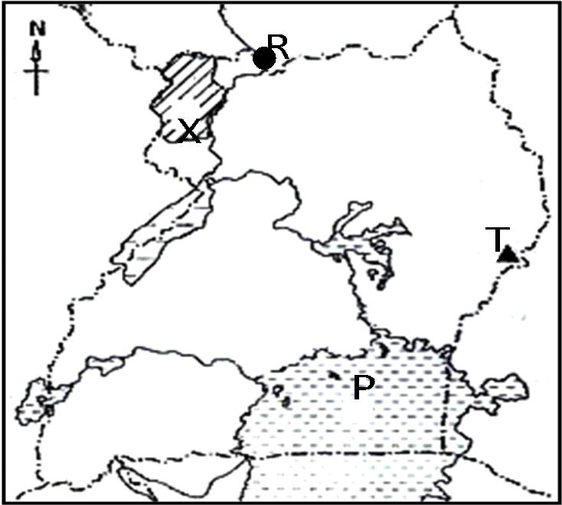***Study the sketch map of Uganda below and answer questions 24 to 26.***

* 1. Mention the main cash crop grown in area marked ***X***.

……………………………………………………………………………………………………………

* 1. Name the main economic activity done in area marked **P**.

……………………………………………………………………………………………………………

* 1. Identify the town labeled **R**.

……………………………………………………………………………………………………………

* 1. Identify any **one** way the government of Uganda is trying to solve the problem of poverty among citizens.

……………………………………………………………………………………………………………

* 1. Mention any **one** river in Africa that serves more than one purpose.

……………………………………………………………………………………………………………

* 1. What title is given to the political head of a Municipality?

……………………………………………………………………………………………………………

* 1. Why did European colonialists use physical features to form boundaries of African countries?

……………………………………………………………………………………………………………

* 1. How do people of Uganda show respect to their national anthem?

……………………………………………………………………………………………………………

* 1. What type of climate supports the growth of citrus fruits?

……………………………………………………………………………………………………………

* 1. Give **one** way missionaries helped in fighting slave trade.

……………………………………………………………………………………………………………

* 1. Why was salt on high demand during Trans-Saharan Trade (TST)?

……………………………………………………………………………………………………………

* 1. Give **one** reason why a person below 18 years is not allowed to participate in national elections.

……………………………………………………………………………………………………………

For each of the questions **36** to **40**, answer **Either** the Christian **OR** Islamic questions **but not both**.

**No marks** will be awarded to a candidate who attempts

**both** alternatives in a particular number.

# EITHER:

* 1. How important were the **Ten Commandments** to the Israelites?

……………………………………………………………………………………………………………

**OR**: How important are **pillars** of Islam to Muslims?

……………………………………………………………………………………………………………

# EITHER:

Name the Angle who brought to the Virgin Mary the message for the birth of Jesus

……………………………………………………………………………………………………………

# OR:

Name the Angle who brought to Mariam the message for the birth of Prophet Isa

……………………………………………………………………………………………………………

# EITHER:

Name the sacrament that makes one to join God’s family.

……………………………………………………………………………………………………………

# OR:

Name the pillar that makes one to join lslam.

……………………………………………………………………………………………………………

# EITHER:

Why do Christians pay tithe?

……………………………………………………………………………………………………………

# OR:

Why do Muslims pay Zakat?

……………………………………………………………………………………………………………

# EITHER:

Which organization unites all Christians in Uganda?

……………………………………………………………………………………………………………

# OR:

Which organization unites all Muslims in Uganda?

……………………………………………………………………………………………………………

# SECTION B: 60 MARKS

**Questions** 41 **to** 55 **carry four marks each.**

* 1. 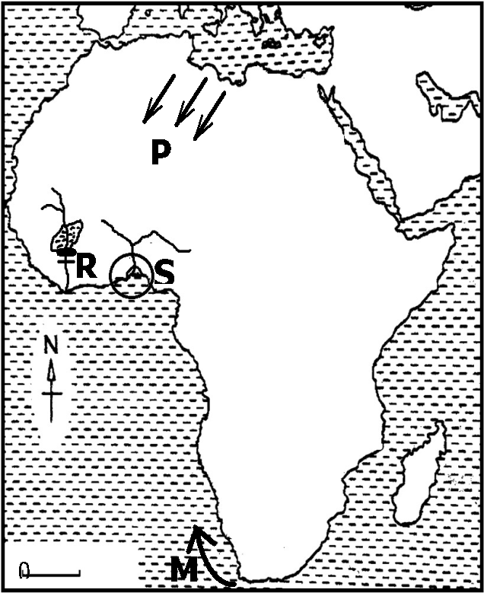Study the sketch map of Africa below and use it to answer the questions that follow.
     1. Name the ocean current marked **M**.

……………………………………………………………………………………………………………

* + 1. Mention any **one** reason why region marked S is densely populated

……………………………………………………………………………………………………………

* + 1. Why does prevailing winds labeled PP cause Sahara desert?

……………………………………………………………………………………………………………

* + 1. Mention **one** way the government of Ghana has benefited from the feature marked R.

……………………………………………………………………………………………………………

42a) Give any **one** reason why African Union was formed.

……………………………………………………………………………………………………………

1. Name any **two** founder member presidents of African Union. (i)……………………………………………………………………………………………… (ii)………………………………………………………………………………………………

c) Why is Durban city important in the formation of African Union?

……………………………………………………………………………………………………………

43 a) What is **fishing**?

……………………………………………………………………………………………………………

……………………………………………………………………………………………………………

1. Why fishing is called an **industry**?

……………………………………………………………………………………………………………

1. Give **one** way the fishing industry has promoted economic development of a country.

……………………………………………………………………………………………………………

1. Give any **one** problem faced by the fishing industry in Uganda.

……………………………………………………………………………………………………………

* 1. Study the sketch map of East Africa and answer questions that follow.

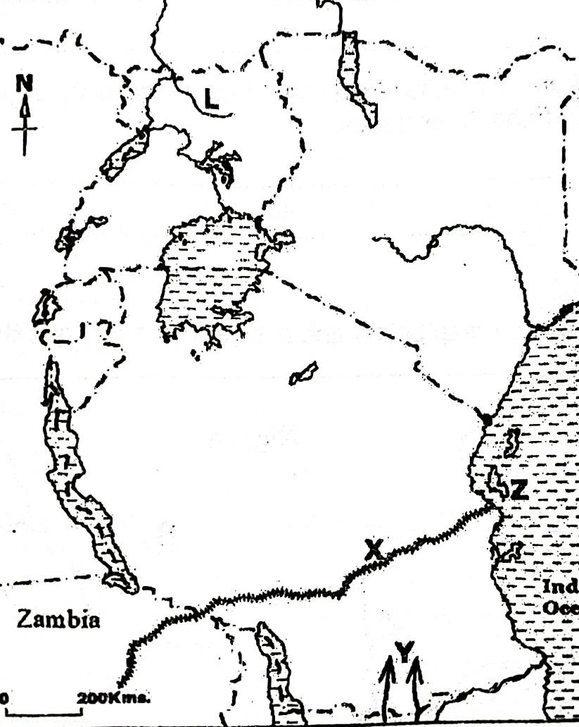

1. Name the river marked **L**

……………………………………………………………………………………………………………

1. Where was the homeland of the ethnic group that entered East Africa using route ***Y***?

……………………………………………………………………………………………………………

1. Mention the traditional cash crop grown on Island marked ***Z***

……………………………………………………………………………………………………………

1. How has the railway line marked ***X*** contributed to the economic development of Zambia?

……………………………………………………………………………………………………………

* 1. Study the climate table below and answer the questions that follow.

|  |  |  |  |  |  |  |  |  |  |  |  |  |
| --- | --- | --- | --- | --- | --- | --- | --- | --- | --- | --- | --- | --- |
| **Month** | **J** | **F** | **M** | **A** | **M** | **J** | **J** | **A** | **S** | **O** | **N** | **D** |
| **Temperature(OC)** | 20 | 21 | 26 | 19 | 25 | 24 | 24 | 26 | 20 | 25 | 29 | 30 |
| **Rainfall (MM)** | 118 | 70 | 200 | 210 | 220 | 70 | 82 | 190 | 120 | 221 | 100 | 70 |

1. Name the type of climate shown in the table above**.**

……………………………………………………………………………………………………………

1. Give one reason to support your answer in **(a)** above**.**

……………………………………………………………………………………………………………

1. Calculate the temperature range.
2. Give one crop that can do well under the above type of Climate named in (a)

…………………………………………………………………………………………………………… 46 a) What was Great Trek?

……………………………………………………………………………………………………………

……………………………………………………………………………………………………………

* 1. Mention any **two** causes of Great Trek. (i)………………………………………………………………………………………………………… (ii)………………………………………………………………………………………………………
  2. How did the Great Trek benefit South Africa economically?

……………………………………………………………………………………………………………

47 a) Give any **two** reasons why the Bantu left their homeland. (i)…………………………………………………………………………………………………………

(ii) ………………………………………………………………………………………………………

b) Mention any **one** negative effect of Bantu migration and settlement into East Africa.

……………………………………………………………………………………………………………

1. How did Mirambo benefit from the coming of the Ngoni who left South Africa due to Shaka Zulu wars?

……………………………………………………………………………………………………………

1. What is **smuggling**?

……………………………………………………………………………………………………………

……………………………………………………………………………………………………………

1. State any **one** way smuggling is dangerous to a country.

……………………………………………………………………………………………………………

1. State any **one** way of controlling smuggling

……………………………………………………………………………………………………………

1. Give **one** way smuggling affects the health sector of a country.

……………………………………………………………………………………………………………

1. Give the meaning of the following terms.
   1. An estuary

……………………………………………………………………………………………………………

* 1. A distributary

……………………………………………………………………………………………………………

* 1. Acataract

……………………………………………………………………………………………………………

* 1. A rapid

……………………………………………………………………………………………………………

1. Why tourism is called an invisible trade?

……………………………………………………………………………………………………………

……………………………………………………………………………………………………………

1. Apart from tourism, give any **one** example of invisible exports of Uganda.

……………………………………………………………………………………………………………

1. Mention any **one** service offered to tourists by the government.

……………………………………………………………………………………………………………

1. Give any **one** way through which government gets money from tourists.

……………………………………………………………………………………………………

For each of the questions **51** to **55**, answer **EITHER** the Christian **OR** Islamic questions but not both. No mark will be awarded to a candidate who attempts both alternatives in a particular number.

# EITHER:

1. What special way of communicating to God did Jesus Christ teach to His disciples?

……………………………………………………………………………………………………………

1. Give any **three** reasons why Jesus Christ emphasized Christians to be prayerful to God.

(i)……………………………………………………………………………………………………

(ii)…………………………………………………………………………………………………

(iii)…………………………………………………………………………………………………

OR:

1. What special way of communicating to Allah did **Prophet Muhammad** (P.B.U.H) teach Muslims to use five time in a day?

……………………………………………………………………………………………………………

1. Give any **three** reasons why Prophet Muhammad (P.BBUBH) emphasized Muslims to be prayerful to Allah.

(i)………………………………………………………………………………………………

(ii)………………………………………………………………………………………………

(iii)………………………………………………………………………………………………

# EITHER:

1. Mention any **two** services you as a child can offer to the Church**.**

(i)…………………………………………………………………………………………………………

(ii)………………………………………………………………………………………………………

1. Give any **two** ways Christians prepare for church service.

(i)……………………………………………………………………………………………………

(ii)…………………………………………………………………………………………………

OR:

1. Mention any two services you as a child can offer to your Mosque.

(i)…………………………………………………………………………………………………………

(ii)………………………………………………………………………………………………………

1. Give any **two** ways Muslims prepare for Jumah service.

(i)…………………………………………………………………………………………………………

(ii)………………………………………………………………………………………………………

53 **EITHER:**

1. What is success?

…………………………………………………………………………………………………………

………………………………………………………………………………………………………

1. Give any one factor that can make a Christian to become successful in life.

…………………………………………………………………………………………………………

1. Give any **two** causes of failure in life of a Christian. (i)………………………………………………………………………………………………

(ii)………………………………………………………………………………………………

# EITHER

**”I say to you, love your enemies**. Do good to those who hate you”

Luke 6:27.

* 1. Who said the above words?

…………………………………………………………………………………………………………

* 1. To whom were the words said?

…………………………………………………………………………………………………………

* 1. Mention **two** things you learn from these quotation. (i)………………………………………………………………………………………………………… (ii)………………………………………………………………………………………………………

OR

# “Verily we have granted you Al Kauthar, turn in prayer to your lord and sacrifice…..”108:1- 3.

1. Who said those words?

2024 SPECIAL MOCK

…………………………………………………………………………………………………………

1. To whom were the words said?

…………………………………………………………………………………………………………

1. Mention any **two** things you learn from the above quotation. (i)………………………………………………………………………………………………………… (ii)………………………………………………………………………………………………………

# FOR BOTH CANDIDATES TO ATTEMPT:

1. Give any **two** similarities in belief between Christians and Moslems. (i)………………………………………………………………………………………………………… (ii)…………………………………………………………………………………………………..……
2. Name the Holy Book used in Christianity / Islam.

………………………………………………………………………………………………………….…

1. Give **one** reason why the book named in (b) is called a Holy Book in Christianity / Islam.

………………………………………………………………………………………………

**END**